JSC "SIA Akonit"
160035 г. 34 Udarnikov St., Vologda, Vologda Region
Phone +7 (8172) 20-90-72 m/k, fax +7 (8172) 20-90-17
www.npoakonit.ru, mail@npoakonit.ru
DATA SHEET
STATIONARY BELT CONVEYOR (KLS)
Company name
Contact person (name, position)
Tel: |  |  |  |  |  |  |  |  |  |  |  |  |  |  |  |  |  |  |  | Email:
Conveyor pos. |  |  |  |  |  |  |  |  |  |  |  |  |  |  |  |  |  |  |  |  |  |  |  |  |  |  |  |  |  |  |  |  |  |  |  |  |  |  |  |  |  |  | Quantity, pcs
MAIN TECHNICAL DATA OF THE CONVEYOR
Belt width, mm |  |  |  | 400 |  |  |  |  |  |  |  |  |  | 500 |  |  |  |  |  |  | 650 |  |  |  | 800 |  |  |  |  |  |  |  | 1000 |  |  |  |  |  |  |  | 1200 |  |  |  |  | 1400 |  |  |  |  |  |  |  |  | 1600 |  | 2000
Capacity, t/h |  |  |  |  |  |  |  |  |  |  |  |  |  |  |  |  |  |  |  |  | Belt speed, m/s |  |  |  |  |  |  |  |  |  |  |  |  |  |  |  |  |  |  |  |  |  |  |  |  |  |  |  |  | Reverse
Conveyor length, m |  |  |  |  |  |  |  |  |  |  |  |  |  |  |  | Rise height, m |  |  |  |  |  |  |  |  |  |  |  |  |  |  |  |  |  |  |  |  |  | Angle of inclination (maximum), gr
Number of loading points |  |  |  |  |  |  |  | Drop height on the belt, m |  |  |  |  |  |  |  |  |  |  |  |  |  |  |  |  |  |  |  |  |  |  | Loading method:
 |  |  |  |  |  |  |  |  |  |  |  |  |  |  |  |  |  |  |  |  |  |  |  |  |  |  |  |  |  |  | from conveyor/feeder |  |  |  |  |  |  |  |  |  |  |  |  |  |  |  |  |  |  |  | from under the hopper
Electrical equipment design
IP | IE |  |  |  | Voltage, V |  |  |  |  |  |  |  |  |  |  |  |  |  |  |  |  |  | General Industrial |  |  |  |  |  |  |  |  |  |  |  |  |  |  |  |  |  |  | Mine Explosion Proof(PB)
Mine-normal (RN) |  |  |  |  |  |  |  |  |  |  |  |  |  |  |  |  |  |  |  |  |  |  |  |  |  |  |  | Mine explosion-proof (RO)
Other type of explosion protection or explosive zone according to Regulations for Electrical Installation:
Need for a control cabinet |  |  |  |  |  |  |  |  |  |  |  |  |  |  |  |  |  |  |  |  |  |  |  |  |  |  |  |  | Need for a local control panel
Consultation required to select the level of explosion protection
Conveyor starter
Hard Start |  |  |  |  |  |  |  |  |  |  | Frequency converter |  |  |  |  |  |  |  |  |  |  |  |  |  |  |  |  |  |  |  |  |  |  |  |  |  |  |  | Soft starter |  |  |  |  |  |  |  |  |  |  |  |  | Hydraulic coupling
Additional Information
CHARACTERISTICS OF TRANSPORTED PRODUCT
Product name
Bulk weight, t / m ³ |  |  |  |  |  |  |  |  |  | Temperature, ⁰ С |  |  |  |  |  |  |  |  |  |  |  |  |  |  |  |  |  |  |  | Piece size max, mm |  |  |  |  |  |  |  |  |  |  |  |  |  |  |  |  |  | Moisture content, %
Properties of the transported product
Sticky |  |  |  |  |  |  |  |  |  |  |  |  |  |  |  |  |  | Abrasive |  |  |  |  |  |  |  |  |  |  |  |  |  |  |  |  |  |  | Fire hazard
Caking |  |  |  |  |  |  |  |  |  |  |  |  |  |  |  |  |  | Dusty |  |  |  |  |  |  |  |  |  |  |  |  |  |  |  |  |  |  | Explosive
Chemically aggressive |  |  |  |  |  |  |  |  |  |  |  |  |  |  |  |  |  | Contains oil |  |  |  |  |  |  |  |  |  |  |  |  |  |  |  |  |  |  | Food-grade
Other properties:
CONVEYOR OPERATION CONDITIONS
Conveyor location
Outdoors |  |  |  |  |  |  |  |  |  |  | Indoors |  |  |  |  |  |  |  |  |  |  |  |  |  | In a mine/pit |  |  |  |  |  |  |  |  |  |  |  |  |  |  |  |  |  |  | Other:
Ambient air temperature, min, ⁰ С |  |  |  |  |  |  |  |  |  |  |  |  |  |  |  |  |  |  | Ambient temperature air, max, ⁰ С |  |  |  |  |  |  |  |  |  |  |  |  |  |  |  |  |  |  |  |  |  |  |  |  |  | Humidity air,%
AVAILABILITY OF ADDITIONAL EQUIPMENT
Tripper |  |  |  |  |  |  |  |  |  |  |  | Travel, m |  |  |  |  |  |  |  |  |  |  |  |  |  |  | Diagonal plow |  |  |  |  |  |  |  |  |  |  |  |  |  |  |  |  |  |  |  |  |  |  |  |  |  |  | Quantity
Weigh-scale |  | Accuracy |  |  |  |  |  |  |  |  |  |  |  |  | iron separator |  |  |  |  |  |  |  |  |  |  |  |  |  |  |  |  |  |  | metal detector |  |  |  |  |  |  |  |  |  |  |  |  |  |  | Sampling Device
Arched cover (corrugated sheets) |  |  |  |  |  |  |  |  |  |  |  |  |  |  |  |  |  |  |  |  |  |  |  | Product cover |  |  |  |  |  |  |  |  |  |  |  |  |  |  |  | Steel flooring on the conveyor flight
Conveyor diagram
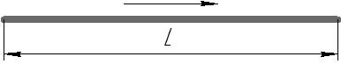 |  |  |  |  |  |  | 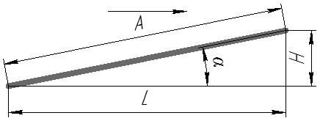 |  |  |  |  |  |  |  |  |  |  |  |  |  |  |  |  |  |  | 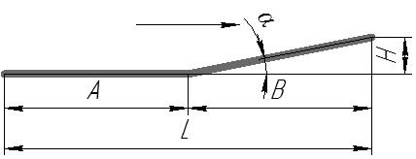 |  |  |  |  |  |  |  |  |  |  |  |  |  |  |  |  |  |  |  |  | 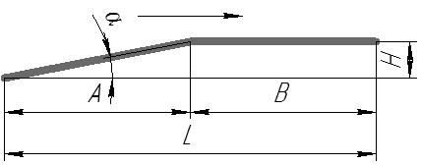
L,m |  |  |  |  |  | α, deg. |  |  |  |  |  |  |  |  |  |  |  |  |  |  |  | A, m |  |  |  |  |  |  |  |  |  |  |  |  |  | H,m |  |  |  |  |  |  |  |  |  |  |  |  |  |  |  |  | H,m
Space for your conveyor layout diagram/additional requirements

